Glenfield Early Learning Centre Newsletter, term 2, 2017
  - A big welcome to our new children since last newsletter: David, Ollie, Carter, Zane, Zoe, Rosie, Olivia and AC. In term 3 we will also have Darius, Jana, Sinchan, Jannah and Brodie all starting in the first week of term. We look forward to getting to know all these new children and their families well.
We have had some great help from our student teachers this term – we were lucky to have year 12 students Ara from Glenfield College and Daniel from Birkenhead College once each week for their work experience. We also welcomed Joy who was here in her final year of training and Neil who was in his first, both with AUT. We are fortunate that we will get to see Neil again in August when he comes back for another 3 weeks. Have you seen the display in GELC about the value these students offer to the centre, the children, the families and the teaching team? It is on the blue wall near the mat-time area – do have a look.
PROFESSIONAL DEVELOPMENT: This term our teaching team have continued with their professional development with the aim to ensure quality outcomes for all children at GELC. Topics covered this term have included: Child Development from a Maori Perspective; Child Protection; Sign Language; Teacher Registration; Managing People; Te Whariki (the revised curriculum), and during the holidays, a workshop on Compliance. It’s not just the children learning at GELC!
FRUIT WEEK: We are loving the support from our families in bringing in a couple of pieces of fruit or vegetables for the children to try in the 3rd week of term. As this week is ‘special’ the children get excited and are often keen to try new foods or eat foods they usually wouldn’t because they see their friends enjoying them. We were pleased to receive so many quality fruits and veggies that we could extend it for another week. Thank you and look out for it again next term. Keep an eye on our secret Facebook page for reminders for the next fruit week.
MARLBOROUGH PRIMARY SCHOOL: This term we organized a trip for all our 4 year olds, and their special adult, to visit Marlborough Primary School. We met outside, then split into two groups and joined in the school experience. Our children got to enjoy ‘Jump Jam’, some brain food, a learning activity and morning tea with the other children at school before heading back to either home or GELC. Feedback was that this was a valuable experience for both children and their parents. We are hoping to visit a different school later in the year – we will keep you informed.
If you would like to join a special group of parents in helping out our centre, please let Paula or Stacey know. We are aiming to build a small group of parents with their own Facebook page, to be our go-to parents for help in organising / running fundraisers, for testing ideas on and helping out in anyway. By joining the group you will not be commiting to anything – but you will get lots of opportunities to see where you can help and you can choose whether you would like to or not.
Message from the front office: When making payments, please either have the exact cash or use EFTPOS as the centre doesn’t keep cash on site. This will make your transactions quicker, and their lives much easier. Thank you.
The budget 2017: Sadly this was not a highlight for us, once again funds invested in Early Childhood Education were all directed at increasing participation rather than supporting quality. At GELC it is important to us to keep our costs affordable to our families while maintaining a centre with high quality practices and teachers. If you can help us with accessing any free or cheap resources please let us know.
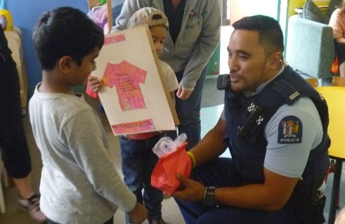
OUR TRIP TO GLENFIELD LIBRARY: Once again we were lucky enough to have Andy come and read us a story, then one week later we went to visit her library. This time we had their manager Jenny tell us a story about Matariki and we were able to explore the new children’s area. We found puzzles, dress-ups and our friend the train from our last visit. It was great to have some parents along to help and join in the fun too.
A VISIT FROM OUR LOCAL COMMUNITY CONSTABLE: The week before Pink Shirt Day, we were grateful to have Farran come and visit us. He talked about keeping safe, showed the children the uniform and let them try on the vests and hats, and then took them to see and sit in the Police car. The children really enjoyed this visit, and we hope Farran enjoyed the biscuits they iced for him in pink and blue.
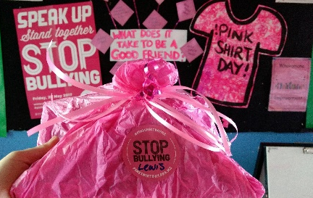
PINK SHIRT DAY: Thanks to all our families for the great support of Pink Shirt Day. This day is all about sending the message that bullying is not okay. This fits with the culture of respect and inclusiveness at GELC and we are happy to spread this message. The teaching team provided some great learning around this topic for the children and it was fantastic to hear the children sharing their ideas as well. Thanks to everyone who dressed in pink on the Friday, and to all who gave a donation which went to Mental Health Foundation.
Books for gold coin donation: The books on display are available to purchase for a gold coin. All funds raised will go towards either resources for the children, or their end-of-year celebration. If you have any books that you think others would enjoy and you would like to donate, we would appreciate that too.
Car-park safety: Just a reminder when it is wet and everyone is rushing to please take care in the car-park. Ensure your child is with you and when driving watch out for children. Many thanks.
FREE PARENTING COURSE: This term we hosted a free parenting course run by The Peace Foundation. We know that parenting is the hardest job there is, so we will go out of our way to find ways to support our parent community. Feedback from those who attended said it was very worthwhile.
OUR FAMILY EVENT: This term we enjoyed an evening of fun and food with our families to celebrate Matariki, the Maori New Year. The children treated us to a mat-time showcasing the waiata (songs) they had learned as well as their smooth moves with the poi. It was lovely to see extended families, and ex GELC children attend. Thanks to all who attended for making this a great night.
Attendance at GELC: While it is important for your child to attend regularly, we thank you for keeping your child home when they are not well. If you are uncertain whether to send your child or not, please ring Paula or Stacey on 444 0818 and we can help you decide.
Message from the front office: Please don’t let your children run around the courtyard area – the tiles are a slip hazard and the noise can be disruptive to other centre users.
Pick-up times reminder: Please note that session end times of 11.30am and 2.30pm must be adhered to. When children are picked up late from the morning session, a teacher is delayed in getting their lunch-break so will miss out on some of the precious child-free half-hour. When children are picked up after 2.30pm, teachers are again delayed in their end-of-day evaluation and end up going home late. These teachers give so much of themselves while on the floor – it is important that their needs are respected too. We appreciate your support in this.
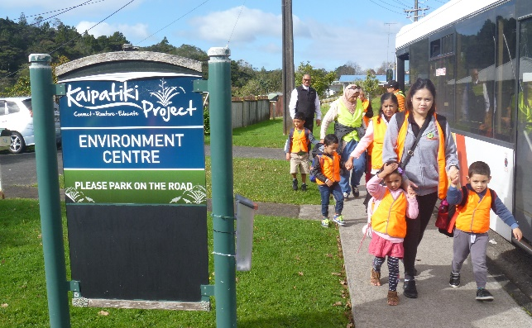
We had a fabulous time on our trip to Kaipatiki Project. We had a go at weaving flowers from flax, planting seedlings, exploring the area, and trying some vegies straight off the plant. The bus trip was pretty exciting too, we went past some of our homes! Once again the trip was only possible because of all the fantastic parent help we were given, and the dedication and hard work of our teaching team. Many thanks to all.
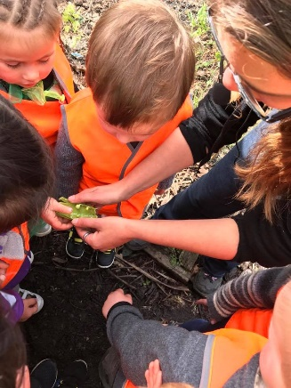
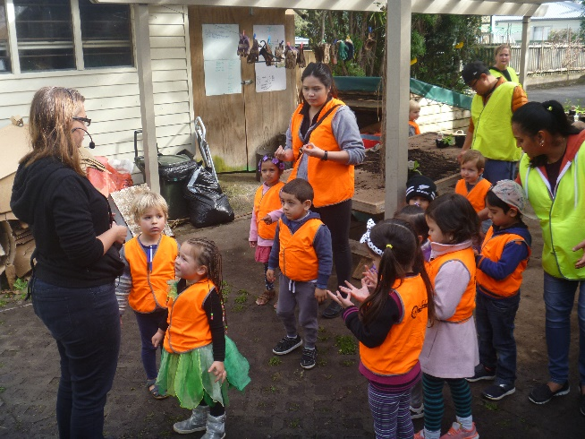
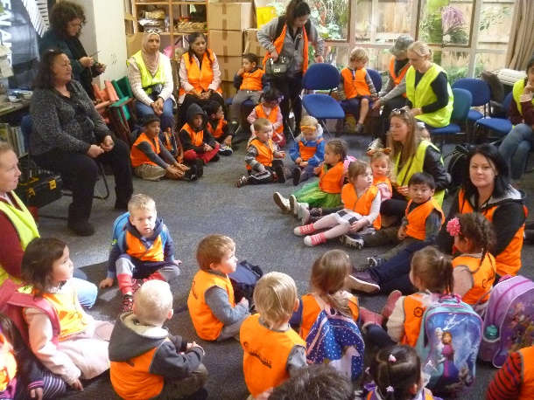
Facebook: Are you connected? Lots of information, photos and items of interest are posted on our secret page just for our families. If you are not yet a member, please see Paula or Stacey so we can add you.
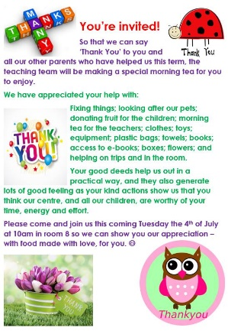
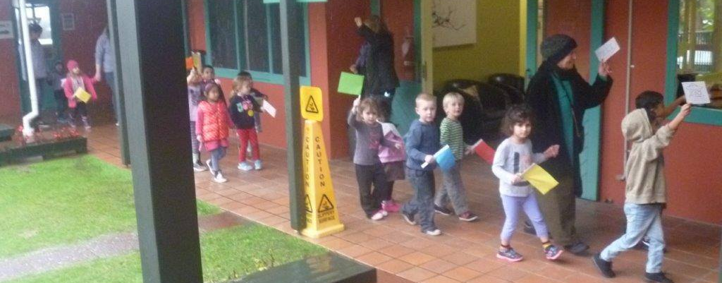
WE HAD A PARADE: To celebrate with Team New Zealand at the same time as the parade in Auckland City. The children made flags and medals and learned a little about current events and the achievements of our country. The rain didn’t dampen our enthusiasm at all and Sandie enjoyed the festivities from the comfort of her office.

Once again we had a morning tea to thank those who have helped us this term. The list of all the kindness and help we have received was very long and gave all the teaching team a reminder of how lucky we are to be surrounded by such caring and generous families and wider community. Thank you all for your support – it’s good for the soul as well as the centre
Your teaching team: Paula, Stacey, Almira, Vee, Joanne and Jessie

